The Black Swan Blog
Innovative, provocative, sometimes slightly crazy concepts in sustainable energy development

06.26.13

Alberta – A Case Study in Wind Energy Management
Posted in Uncategorized at 2:53 pm by Administrator
I have personally been promoting the use of alternative energy for more than 30 years, from the time when I was acting as an energy adviser to the Official Opposition in the Province of Alberta, Canada.
Alberta is rich in hydro-carbons including conventional and heavy oil, natural gas and tar sands. But it is also rich in wind and solar energy resources. I was arguing at that time that it made sense to use royalty revenues from hydro-carbons to fund the development of an alternative energy industry.
It took a while but eventually Alberta got on the alternative energy bandwagon which resulted in the deployment of the first wind turbines in Canada in 1993. The wind industry increased capacity at a steady rate and Alberta retained its position as the Province with the most wind capacity until about 2005. By that time there was about 500 MW of wind nameplate capacity and the Provincial grid operator, AESO, placed a moratorium on further wind development until the impact on the stability and reliability of the electricity generation and distribution system could be assessed. The moratorium was lifted in 2007 despite ongoing concerns on the part of AESO – concerns which have resulted in a series of studies into the best way to integrate more wind generation. Development of wind resources resumed and by the end of 2012 Alberta had just under 1.1 GW of nameplate wind capacity installed.
Over the period from 2008 to 2012 electricity peak demand in Alberta grew from 9.8 GW to 10.6 GW, an increase of about 0.8 GW or just over 9%. To preserve a healthy reserve a number of additional generating facilities were brought on-line with the largest increases in the categories of Cogen (which in Alberta are Natural Gas fired facilities supporting Oil & Gas operations), "Peakers" (natural gas-fired single cycle plants) and wind.
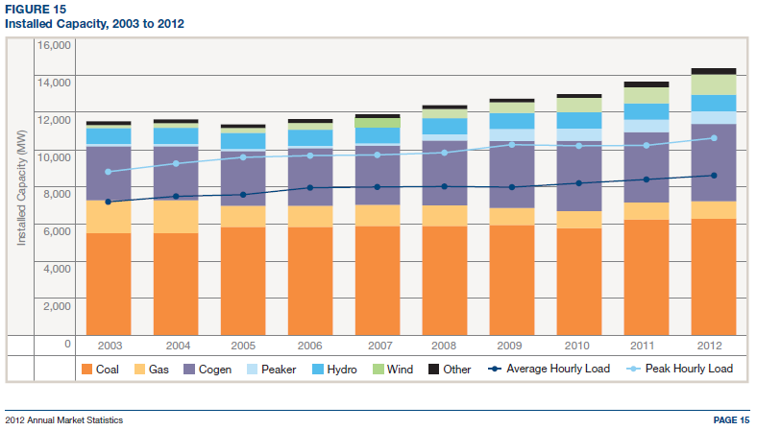
Total generation nameplate additions during this period were about 2 GW which should have provided more than enough electricity to meet the increased demand. However, imports of electricity from the neighbouring province of British Columbia increased quite dramatically rising from 2.2 GW-Hours to 3.6 GW-Hours. This amounts to an average import capacity increase of approximately 160 MW which is, somewhat ironically, almost identical to the increase in net wind capacity developed over the same time period.
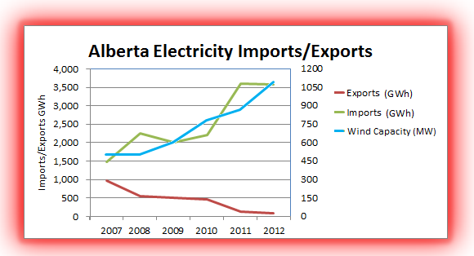
This does not seem to make sense. Alberta has a surplus of generating capacity, even without considering wind at all, yet imports have increased significantly. Have we observed such an odd combination of facts before with regard to the electricity generation and distribution industry? In fact, we have.
As I have outlined in my previous blog postings about California and Europe the introduction of significant amounts of wind generation capacity results in an electrodox – an electricity paradox where an over-supply of generation capacity that includes wind results in increased net electricity imports.
The problem with wind generation is that it varies dramatically over short periods of time. The graphs below show the variability of wind generation in Alberta for the whole of 2012 as well as the percentage of generation hours by MW (data taken from the AESO site).
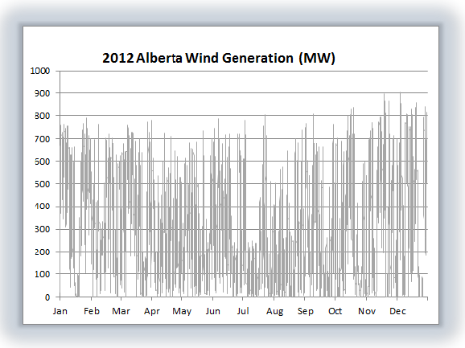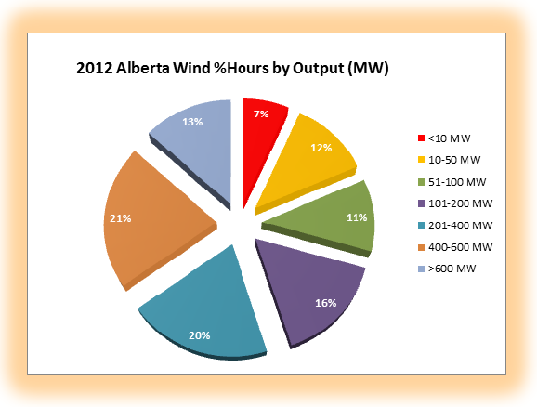
These graphs are enough to make any transmission regulator have a lot of sleepless nights.
The speed at which the wind generation ramps up and down is too fast for a response from a thermal generation plant. Base-load coal or natural gas-fired plants can take as much as an hour to change their output in a significant way. Even "peaker" plants take up to 15-20 minutes.
The only large scale electricity generation sources that can follow the wind variability trends are hydro and nuclear. And hydro is exactly what British Columbia has an abundance of. In order to deal with the variability of wind Alberta is forced to import electricity from British Columbia even though there is plenty of reserve capacity within the Alberta system.
From the perspective of actually trying to run a generation system primarily using wind the pie chart is particularly worrisome.
For 7% of the time there was essentially no wind generation at all (less than 1% of nameplate capacity). That implies that for more than an hour a day, happening at some random time, there will be no wind available which means that another reliable source will have to be on standby to be dispatched on very short notice. In fact, for about 30% of the time – 8 hours per day – wind generation is less than 10% of nameplate capacity.
AESO (the Alberta Electricity System Operator) recently completed a pilot project in which they attempted to "dispatch" wind in the sense that various wind farm operators would offer specified amounts of wind energy to the grid operator based upon real-time wind forecasts. If successful, that would allow wind generators to compete with other generators in the Merit Order market.
Although there were some positive aspects of this approach, it was found that forecasts even within 20 minutes of delivery had wind producers failing to deliver energy within the Allowable Dispatch Variance about 8% of the time. In other words, forecasting wind is really difficult. And 20 minutes is not a lot of time to give the system operator to line up alternative generation sources.
Realistically, all things considered, the bottom line is that Alberta really can't rely upon wind as a generation source. That implies that a complete duplicate generation system must in place in order to step up electricity production when the wind fades or reduce electricity production when the wind ramps up.
Some will argue that Alberta is not a good model because of the geographic concentration of wind generation in the SW corner of the province. That is true. But in other parts of the world the very best wind generation sources typically occur in clusters. So the same problems that Alberta faces will be encountered elsewhere.
So is this a hopeless case? Not at all. Energy storage solutions will allow time-shifting of wind generation to match demand. Unfortunately, there are no reasonably priced energy storage solutions available today.
The recent Phoenix-like emergence of Beacon Power is a positive sign for the industry. The Beacon system of high tech flywheels installed at Stephentown, New York can provide 20 MW of electricity on demand almost instantaneously – but only for about 15 minutes. The system cost $43 million making the storage cost about $43/(20 MW *.25 hours) = $8 million/MW-hour. That's even worse than the battery based system installed recently by Duke energy in Texas which cost about $5 million/MW-hour.
Discussions about costs/MW-hour can be confusing so let me clarify what I mean by the numbers quoted above.
The largest wind farm built in Alberta to date is the Halkirk Wind Project which cost $357 million and has a nameplate capacity of 83 x 1.8 = 150 MW. On a windy night this facility could easily generate at 70% of capacity for 6 hours or more even though the demand for electricity would probably be very low and prices could be close to zero. If this energy could be stored it could be sold the next day during peak demand time for a much better return.
The storage required to accomplish that time-shifting would be 0.7 * 150 MW * 6 hours = 630 MW-Hours. Using a battery storage system such as that installed by Duke the cost would be more than $3 billion. A system from Beacon Power would be $5 billion. Clearly these kinds of costs could never be recovered by reselling the stored electricity in any reasonable electricity market. So new and much cheaper storage technology is key.
But just as important as technology improvements are required changes to the practices of grid operators.
In Alberta AESO is still trying to determine the appropriate tariff to charge energy storage operators for use of the transmission grid (see section 5.1.6 in the Energy Storage Initiative Issue Identification). The very existence of such as discussion demonstrates a significant problem with the way energy storage systems are viewed.
Energy storage is critical to the health of the transmission grid and to the ability to transition to a sustainable energy environment. Energy storage system operators should be paid by the grid for their services – not the other way around!
Beacon Power has risen from the ashes principally due a Federal Energy Commission ruling that provides for a premium price for the speed at which electricity can be delivered. That provision plays to the strengths of energy storage systems and is definitely a move in the right direction. A coordinated North American (or global) policy that supports the development of energy storage systems in the same way would provide welcome support for the developers of this technology.
In summary, the Alberta situation demonstrates all of the characteristics that will be common to wind energy development anywhere in the world. Wind is a highly variable source of electricity generation which will require stabilization through access to energy storage – either through imports of fast-response generation from other jurisdictions or through the development of new technology.
Energy transmission policy needs to evolve to become supportive of energy storage solutions.
Until these problems are overcome Alberta will continue to rely upon traditional thermal generation and the further expansion of wind farms will be largely depend upon renewable energy support mechanisms of one sort or another.

